IACUC Training Exercise #4 - 2015
The following exercise may be useful in stimulating discussion regarding compliance with PHS Policy and VA Handbook 1200.07. To facilitate discussion, pages 1-3 of the exercise may be distributed to the IACUC members prior to a meeting. After a few minutes of discussion about the exercise during the meeting, the remainder of the exercise may be distributed to provide ideas for the committee’s consideration.

Dr. Jones was a new investigator at the Hometown VAMC; he decided it would be a good idea to meet with Ann Marie, the Hometown VAMC-IACUC Manager, before he submits his first ACORP for IACUC review. He made an appointment with Ann Marie for 1:00 pm on Tuesday afternoon and said he would email his draft ACORP for her review prior to their meeting. Shortly thereafter, Ann Marie received an email from Dr. Jones’ with his draft ACORP attached. As Ann Marie scanned the draft ACORP, she noticed Dr. Jones had filled out Appendix 9 (see page 2) apparently because of the method of euthanasia proposed. The conscientious Ann Marie pulled out her copy of the Guide and the AVMA Guidelines for the Euthanasia of Animals: 2013 Edition. After finishing her review of the draft ACORP, Ann Marie decided that Dr. Jones needed to come prepared for their meeting so she emailed him a copy of the VA Deviations and Departures flowchart (see page 3) and suggested he review a few of the optional IACUC training exercises found on the VA - Use of Animals in Research webpage (see link: http://www.research.va.gov/programs/animal_research/).
What problems do you think Ann Marie found when she reviewed Dr. Jones’ Appendix 9?

The Appendix 9 of Dr. Jones’ ACORP that Ann Marie reviewed is shown below; please note this Appendix 9 (verbatim) was submitted for JIT secondary veterinary review.

ACORP Appendix 9
DEPARTURES FROM “MUST” AND “SHOULD” STANDARDS IN THE GUIDE (2011)

For each IACUC-approved “departure” of this protocol from a “Must” or “Should” standard in the Guide, provide the following information. (Consult the IACUC or the Attending Veterinarian for help in determining whether any “departures” are involved.):

Copy the lines below for each departure.
Briefly summarize the “Must” or “Should” standard, and provide the number(s) of the page(s) on which it appears in the Guide.

► Euthanasia by Decapitation without anaesthesia:
AVMA Guidelines (2013) Page 61, Section S2.2.2.3: Small Lab Animals (Rats), Acceptable with Conditions Methods, Physical methods, Decapitation
“Decapitation is used in lab settings because it yields tissues uncontaminated by chemical agents. Loss of cortical function is rapid and occurs within 5-30 seconds. ”

Describe the specific alternate standard(s) that will be met on this protocol, and how they will be monitored.
► Decapitation is acceptable with conditions for rodents:
1. Use of a specialized rat guillotine, maintained in good condition with sharp blades.
2. Personnel will be or have been trained on anaesthetized and/or dead animals to demonstrate proficiency. Only trained personnel are allowed to euthanize animals on this protocol.
3. We will use restraints (Decapicones, transparent plastic cones open at the end) to prevent excess moving around of rats just prior to decapitation, which allows the procedure to be done quickly and reduce unnecessary distress on the animals.

Provide the scientific, veterinary medical or animal welfare considerations that justify this departure

►In this study, we plan to determine post-mortem levels of monoamines (serotonin and dopamine) and monoamine receptor levels in brain regions involved in depression. Inhalant agents and barbiturates are documented to alter monoamine transporter function (el-Maghrabi and Eckenhoff., 1993; Fink-Jensen et al., 1994; Mantz et al., 1994) and would prevent accurate measurement of rat brain monoamines in our study. A physical method of euthanasia without sedation is therefore necessary in this study.
Description: Decapicones (tapered plastic tubes, Braintree Scientific Inc.) will be used to restrain rats prior to live decapitation using a guillotine, a process that is quick and relatively stress-free for the animals. The guillotine is cleaned with soap and water immediately after each use and rinsed with 70% ethanol prior to use again. The guillotine is maintained with a sharp blade to provide instant decapitation.

• El-Maghrabi, EA, and RG Eckenhoff (1993) Inhibition of dopaminergic transport in rat brain synaptosomes by volatile anesthetics. Anesthesiology 78: 750.
• Fink-Jensen A, SH Ingwersen, PG Nielsen, L Hansen, EB Neilsen and AJ Hansen (1994) Halothane anesthesia enhances the effect of dopamine uptake inhibition on interstitial levels of striatal dopamine. N. Sch. Arch. Pharmacol. 350:239.
Mantz, J., C Varlet, JB Lecharny, D Henzel, P Lenot and JM Desmonts (1994) Effects of volatile anesthetics, thiopental and ketamine on spontaneous and depolarization-evoked dopamine release from striatal synaptosomes in the rat. Anesthesiology 80: 352.

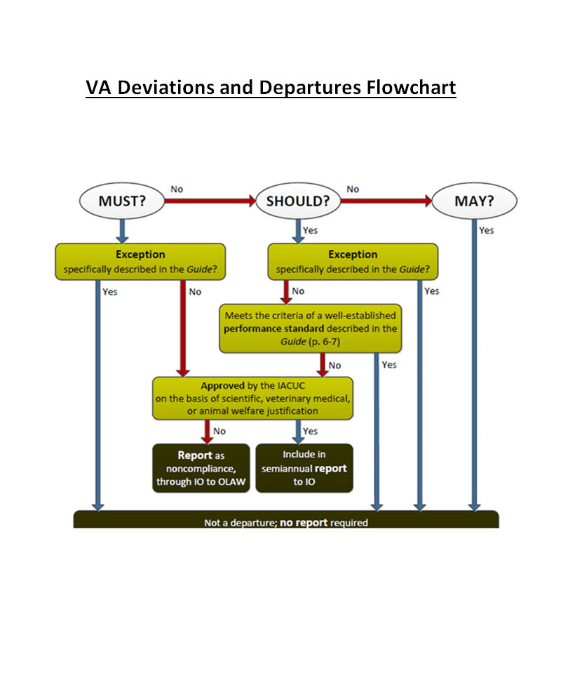

Ann Marie’s comments regarding Dr. Jones’ Appendix 9, which she discussed with him, are shown below in red font.
Example #2
ACORP Appendix 9
DEPARTURES FROM “MUST” AND “SHOULD” STANDARDS IN THE GUIDE (2011)

For each IACUC-approved “departure” of this protocol from a “Must” or “Should” standard in the Guide, provide the following information. (Consult the IACUC or the Attending Veterinarian for help in determining whether any “departures” are involved.):

Copy the lines below for each departure.
Briefly summarize the “Must” or “Should” standard, and provide the number(s) of the page(s) on which it appears in the Guide.

► Euthanasia by Decapitation without anaesthesia:
AVMA Guidelines (2013) Page 61, Section S2.2.2.3: Small Lab Animals (Rats), Acceptable with Conditions Methods, Physical methods, Decapitation
“Decapitation is used in lab settings because it yields tissues uncontaminated by chemical agents. Loss of cortical function is rapid and occurs within 5-30 seconds. ”
- The above is a quotation from the AVMA Guidelines for the Euthanasia of Animals: 2013 Edition not the Guide.
- The AVMA Guidelines’ page number referenced is incorrect; the page number should be 49.
- The applicable text from the Guide is shown below:
“Euthanasia is the act of humanely killing animals by methods that induce rapid unconsciousness and death without pain or distress. Unless a deviation is justified for scientific or medical reasons, methods should be consistent with the AVMA Guidelines on Euthanasia (AVMA 2007 or later editions).” Page 123

Describe the specific alternate standard(s) that will be met on this protocol, and how they will be monitored.
► Decapitation is acceptable with conditions for rodents:
1. Use of a specialized rat guillotine, maintained in good condition with sharp blades.
2. Personnel will be or have been trained on anaesthetized and/or dead animals to demonstrate proficiency. Only trained personnel are allowed to euthanize animals on this protocol.
3. We will use restraints (Decapicones, transparent plastic cones open at the end) to prevent excess moving around of rats just prior to decapitation, which allows the procedure to be done quickly and reduce unnecessary distress on the animals.

The method of euthanasia described above (decapitation - acceptable with conditions) adheres to the recommendations listed in the AVMA Guidelines for the Euthanasia of Animals: 2013 Edition.

Provide the scientific, veterinary medical or animal welfare considerations that justify this departure

►In this study, we plan to determine post-mortem levels of monoamines (serotonin and dopamine) and monoamine receptor levels in brain regions involved in depression. Inhalant agents and barbiturates are documented to alter monoamine transporter function (el-Maghrabiand Eckenhoff., 1993; Fink-Jensen et al., 1994; Mantz et al., 1994) and would prevent accurate measurement of rat brain monoamines in our study. A physical method of euthanasia without sedation is therefore necessary in this study.
Description: Decapicones (tapered plastic tubes, Braintree Scientific Inc.) will be used to restrain rats prior to live decapitation using a guillotine, a process that is quick and relatively stress-free for the animals. The guillotine is cleaned with soap and water immediately after each use and rinsed with 70% ethanol prior to use again. The guillotine is maintained with a sharp blade to provide instant decapitation.

• El-Maghrabi, EA, and RG Eckenhoff (1993) Inhibition of dopaminergic transport in rat brain synaptosomes by volatile anesthetics. Anesthesiology 78: 750.
• Fink-Jensen A, SH Ingwersen, PG Nielsen, L Hansen, EB Neilsen and AJ Hansen (1994) Halothane anesthesia enhances the effect of dopamine uptake inhibition on interstitial levels of striatal dopamine. N. Sch. Arch. Pharmacol. 350:239.
Mantz, J., C Varlet, JB Lecharny, D Henzel, P Lenot and JM Desmonts (1994) Effects of volatile anesthetics, thiopental and ketamine on spontaneous and depolarization-evoked dopamine release from striatal synaptosomes in the rat. Anesthesiology 80: 352.
• Fink-Jensen A, SH Ingwersen, PG Nielsen, L Hansen, EB Neilsen and AJ Hansen (1994) Halothane anesthesia enhances the effect of dopamine uptake inhibition on interstitial levels of striatal dopamine. N. Sch. Arch. Pharmacol. 350:239.
Mantz, J., C Varlet, JB Lecharny, D Henzel, P Lenot and JM Desmonts (1994) Effects of volatile anesthetics, thiopental and ketamine on spontaneous and depolarization-evoked dopamine release from striatal synaptosomes in the rat. Anesthesiology 80: 352.

The AVMA Guidelines for the Euthanasia of Animals: 2013 Edition state “This method is acceptable with conditions if performed correctly and it may be used in research setting when its use is required by the experimental design and approved by the IACUC.” (Page 39) The investigator has provided a scientific justification for the use of decapitation and included supporting literature citations, which were approved by the IACUC; therefore, no deviation from the Guide has occurred. Appendix 9 is not applicable and should be deleted.

After a moment of reflection and referring to the VA Flowchart on page 3, Dr. Jones’ has a revelation; he thinks he now knows when not to complete an Appendix 9.
If I (Dr. Jones) propose: | Appendix 9 | Rationale
to perform decapitation without anesthesia on mice, and meet all the criteria for this method to be an acceptable method with conditions. | is not  needed. | The method is consistent with AVMA euthanasia recommendations. No deviation from the Guide.
to perform decapitation on mice without anesthesia with a device* other than a specialized rodent guillotine because studies suggest contact with the guillotine metal blades may alter experimental results.  *shown to be humane and effective | is not  needed. | The Guide says “Unless a deviation is justified for scientific or medical reason, methods should be consistent with the AMVA Guidelines on Euthanasia…” (Page 123). This is a deviation from a “should” statement according to a specifically established exception in the Guide based on a scientific justification. Exceptions are not departures.
Ann Marie says you’ve got it; just remember that specifically established exceptions are protocol specific.

