Instructions for Completion of the

ACORP Appendix 9 -- Departures from “Must” and “Should” Standards in the Guide

(ACORP App. 9 Instructions)
Version 4

These instructions provide detailed guidance on completing Appendix 9 of the ACORP, and are referenced to the numbers of the items in Appendix 9. ONLY complete this appendix if it is relevant to the protocol being submitted for review.

Always use the most recent version of Appendix 9 of the ACORP, available at http://www.research.va.gov/programs/animal_research/, when preparing a protocol for IACUC review. In general, no protocol should be submitted to the IACUC on an older version of the ACORP forms more than 1 year after a newer one becomes available, although protocols already approved by the IACUC less than 1 year after release of a newer version will be accepted for Just-In-Time review for three years after approval by the IACUC.

Regulatory documents mentioned in the instructions are abbreviated as follows:
Guide – Guide for the Care and Use of Laboratory Animals, 8th ed., 2011
OLAW FAQs – Frequently Asked Questions – PHS Policy on Humane Care and Use of Laboratory Animals (http://grants.nih.gov/grants/olaw/faqs.htm)
PHS Policy – Public Health Service Policy on Humane Care and Use of Laboratory Animals

General Instructions:
Answer each question by completing the table provided or entering the requested information at the ►. Enter “N/A” for any item that does not apply to this protocol. The sections of the form will expand as needed.
To check an item, type “X” inside the ( ) provided.
Define each abbreviation the first time it is used.
Rows may be added to any of the tables in the form – to add a row to the bottom of a table, position the cursor in the far right cell of the bottom row, and press <Tab>. All Table Tools available when the cursor is placed in the table are also active.

Header for Every Page. Enter the same information in the header for this appendix as is entered in the header for the Main Body of the ACORP to which it applies, to identify each page of this Appendix with that ACORP:
PI’s last name
Protocol No. Assigned by the IACUC – a unique identifier for each protocol, to be assigned locally by the IACUC of Record to the protocol as a whole
Official Date of Approval – the date of final and unequivocal approval by the IACUC, as defined in the PHS Assurance, which determines the due dates of the first annual continuing review and the triennial de novo review, as applicable

PHS Policy (IV.B.3) requires that IACUC-approved departures from PHS Policy, including the provisions of the Guide, be reported to the Institutional Official in the report of each semiannual evaluation of the institutional animal care and use program. This appendix is to document the departures that have been approved by the IACUC for this protocol. The completed appendix may be copied for inclusion in semiannual reports.

Consider each instance in this protocol that requires care or use of animals in a way that does not meet the general standards described in the Guide. These are all considered “deviations”, and most commonly appear in Items C.2.c, M, T, U, and V, and Appendices 2, 4, 5, 6, and 7 of the ACORP (procedures, husbandry, endpoint criteria, euthanasia, antibody production, antemortem specimen collection, surgery, transportation). Apply the series of test questions below to determine whether any of the “deviations” are considered “departures” and therefore must be documented in Appendix 9 (see also OLAW FAQs C.7):

1. Does the Guide describe the general standard as a “May” standard? If so, this is NOT a “departure”, and need not be documented in Appendix 9. Otherwise, for any “Should” or “Must” standard, proceed to the next question.

2. Does the Guide include an explicitly stated exception that allows for the “deviation”? If so, this is NOT a “departure”, and need not be documented in Appendix 9. Otherwise, proceed to the next question.

3. Does the “deviation” meet a well-established performance standard for a “Should” standard, according to locally-defined and continuously monitored performance measures? If so, this is NOT a “departure”, and need not be documented in Appendix 9. Otherwise, this IS a “departure”, and may be approved by the IACUC only if justified on scientific, veterinary medical, or animal welfare grounds.

The test questions above are summarized in the following flow chart: 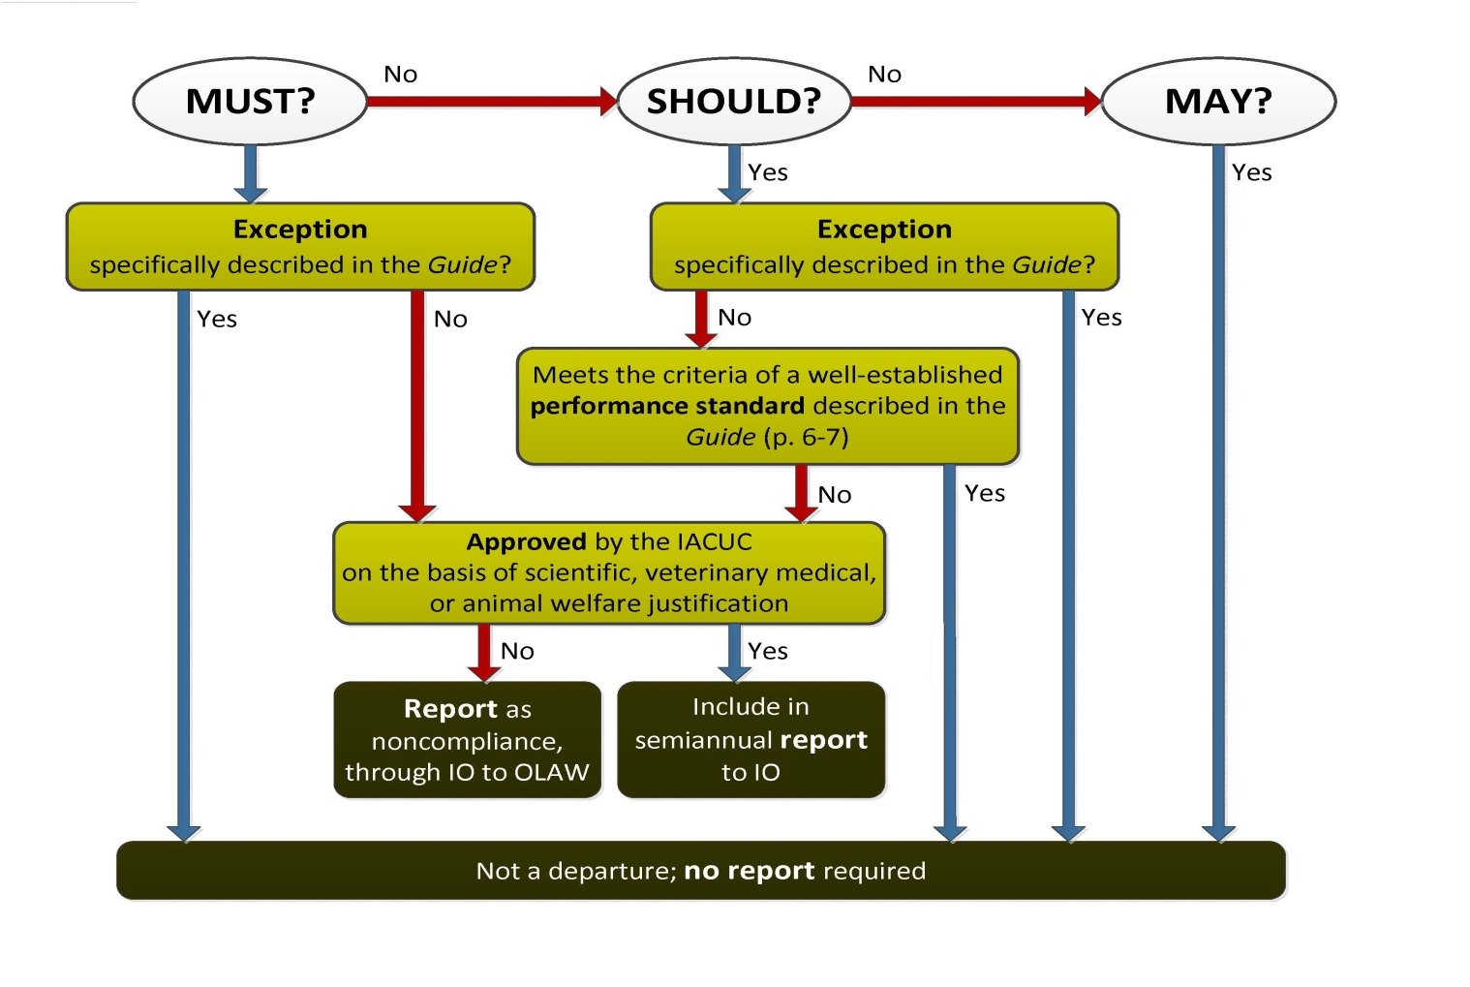
For each IACUC-approved departure included in this protocol, provide the following information:

Briefly summarize the standard that is described in the Guide and reference the page numbers on which it appears.

Describe the specific alternate standard(s) that will be met on this protocol, and how they will be monitored.

Provide the specific scientific, veterinary medical, or animal welfare considerations that justify this departure.

