Frequently asked questions – POU AMP
- What is the POU AMP?
Answer: The Pain/Opioid Use Actively Managed Portfolio (POU AMP) has been established as a shared cross-service portfolio with representation from BLR&D, CSR&D, HSR&D and RR&D. The focus of the POU AMP will be to review preclinical, translational, clinical, rehabilitation, and health services/implementation research applications where pain and opioid use, and the consequences of opioid use, are the primary outcome(s) of the study.
- What funding opportunities are available under the POU AMP?
Answer: The POU AMP has 3 merit Request For Applications (RFAs):
1) The Broad Parent POU AMP RFA funds preclinical, translational, observational, behavioral, epidemiological, and health services/implementation research applications focusing on Pain and Opioid Use.
2) A companion Clinical Trial POU AMP RFA for investigator-initiated single and multi-site clinical trials on painful conditions and opioid use in Veterans.
3) A focused RFA on pharmacogenomics and biomarkers
Veteran engagement is part of the POU AMP RFAs for clinical research and trials as an unscored criteria for BX, RX and CX RFAs and a scored criteria for HSRD-focused applications.
- When will I be able to apply? Are these RFAs offered for Future submission Rounds?
Answer: Applications for Rehabilitation and Health Services Research will be accepted for the Winter round, with Pre-applications due on November 1 and full applications due in early December. POU AMP RFAs will continue to be available for future Merit submission rounds as well. Applications will follow the general service timelines (Spring/Fall for BLR&D and CSR&D, and Summer/Winter for HSR&D and RR&D oriented applications); however, they may not have the exact deadlines as the other Parent RFAs in all services. Please check the due dates in the POU AMP RFA
- Is a Letter of Intent required?
Answer: A pre-application is required. Pease refer to BX-23-200, CX-23-200, RX-23-200 and HX-23-200 (Pre-Application RFA for the POU AMP). A Pre-application is required for all POU AMP RFAs and must be submitted through eRA. Please check the due dates in the POU AMP RFAs and Pre-application.
- Does this mean other HSR&D, BLR&D and CSR&D RFAs will require a pre-application (I02) through eRA? How about other requirements?
Answer: No, currently, the only RFAs that require pre-applications are all RR&D RFAs and three cross-service Pain/Opioid AMP RFAs. Other HSR&D RFAs will still use the Intent to Submit process through ART and other BLR&D and CSR&D RFAs will follow the current LOI requirements for those services, if required by the RFA. Please see the submission requirements for each individual RFA.
- What are the budget caps for the POU AMP RFAs?
Answer:
1) Parent and focused RFA: PD/PIs may request funding for a maximum of four (4) years, based on the total project maximum amount outlined below. There is no annual budget cap; thus, variable funding may be utilized as long as the overall budget cap (based on years requested) is maintained. The salary for all personnel, including the contact PD/PI is included in this cap.
1 year = $300,000 max 2 years = $600,000 max
3 years = $900,000 max 4 years = $1,200,000 max
2) Clinical Trial RFA Budget:
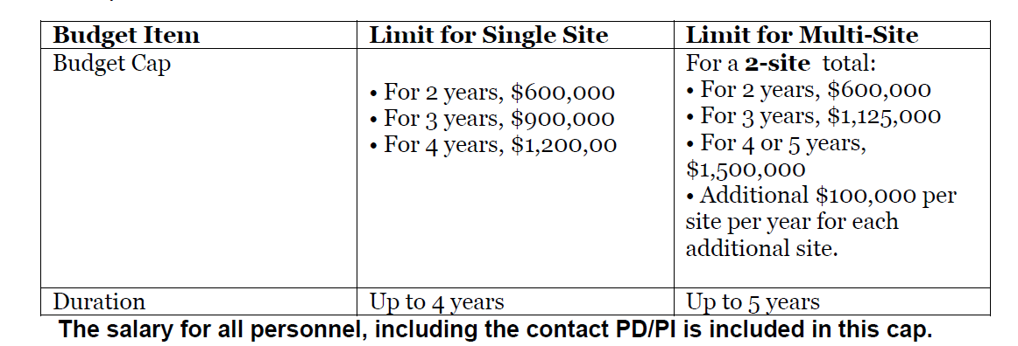
- Where can I find the RFAs?
Answer: The RFAs are now posted on the RFA page of the ORD intranet site at https://vaww.research.va.gov/funding/rfa.cfm (available on the VA intranet, only). Look under the section for ORD Wide Requests for Applications
- How do I decide which service/RFA to apply to?
Answer: Please reach out to POU AMP Scientific POCs:
- BLR&D: Dr. Carol Fowler; Carol.fowler@va.gov
- CSR&D: Dr. Jayanthi Sankar; Jayanthi.sankar@va.gov
- HSR&D: Dr. Cathie Plouzek; Cathie.plouzek@va.gov
- RR&D: Dr. Audrey Kusiak; Audrey.kusiak@va.gov
- Do we need to do a full preapplication for resubmission of proposals?
Answer: Preapplications are required for both new projects and resubmissions. If you are resubmitting a proposal that was previously reviewed on the POU AMP RFAs, you would have to submit a pre-application for each submission. Please see the instructions in the Pre-Application RFAs (i.e. BX-23-200, CX-23-200, RX-23-200 or HX-23-200) for full instructions on resubmissions.
- Are there any changes to non-VA investigators role - their salary and involvement?
Answer: Please see the RFAs for more guidance, but briefly: Non-VA investigators who have an M.D./Ph.D. equivalent are eligible to serve in the role of Co-investigator, but they cannot be listed as such on the budget. The Co-investigator role may be described in the proposal narrative. On the budget they should be reflected as a consultant or as:
- having an Intergovernmental Personnel Act (IPA) assignment, if appropriate. If they are providing research services to VA through a contract, the cost of the contract should be included on the budget forms under all other expenses. Collaborators from outside of the U.S. may only serve as unpaid consultants.
- A Site PI must meet the same qualifications as a Study PI; this includes a minimum of a 5/8th VA appointment or waiver of the 5/8th appointment eligibility requirement, a M.D./Ph.D. or equivalent.
- See Program Guide 1200.15: Eligibility for VA Research Support for additional guidance.

